RF Planar Filter Technologies

Professor Jiasheng Hong, DPhil (Oxford), Fellow of IEEE
Institute of Sensors, Signals and Systems
School of Engineering and Physical Sciences
Heriot Watt University, Edinburgh, UK
https://tesla-itn.hw.ac.uk/

Abstract of the talk

RF filters are a key component in many RF and electromagnetic (EM) systems to control valuable radio frequency (RF) spectrum, e.g. selecting desired frequencies and suppressing unwanted interferences, for many applications including wireless communications and radar. This talk will introduce some novel concepts and advanced technologies for research and development (R&D) of RF planar filters. Several filter examples will be demonstrated in light of EM simulated and measured results. Circuit and network approaches that are useful for design of RF filters will also be introduced and demonstrated using typical examples.

Biography of the speaker
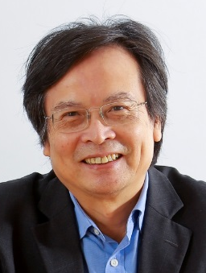
Jiasheng Hong received the D.Phil. degree in engineering science from the University of Oxford, Oxford, U.K., in 1994. His doctoral dissertation concerned EM theory and applications. In 1994, he joined the University of Birmingham, Birmingham, U.K., where he was involved with microwave applications of high-temperature superconductors, EM modelling, and circuit optimization. In 2001, he joined the Department of Electrical, Electronic and Computer Engineering, Heriot-Watt University, Edinburgh, U.K., and is currently a Professor leading a team for research into advanced RF/microwave device technologies. He has authored and coauthored over 200 journal and conference papers in this field, and has published four relevant books - Microstrip Filters for RF/Microwave Applications (Wiley, 1st ed., 2001, 2nd ed., 2011), RF and Microwave Coupled-Line Circuits (Artech House, 2nd ed., 2007), Balanced Microwave Filters (Wiley, 2018), and Advances in Planar Filters Design (The Institution of Engineering and Technology (IET), 2019). His current interests involve RF/microwave devices, such as antennas and filters, for wireless communications and radar systems, as well as novel material and device technologies including multilayer circuit technologies using package materials such as LCP and LTCC, Additive manufacturing or 3D printing device technologies, RF MEMS, ferroelectric and high-temperature superconducting devices.

Professor Hong is a Fellow of IEEE, elected for his outstanding contributions to RF/microwave planar filter technologies. He is also an active member of the IEEE MTT Technical Committees of Filters and Passive Components and Microwave Superconductivity, the Subject Editor (Microwave) for Electronics Letters, an Associate Editor of IET Microwaves, Antennas & Propagation and International Journal of RF and Microwave Computer Aided Engineering. He was also a past Associate Editor of IEEE Transactions on Microwave Theory and Techniques.

